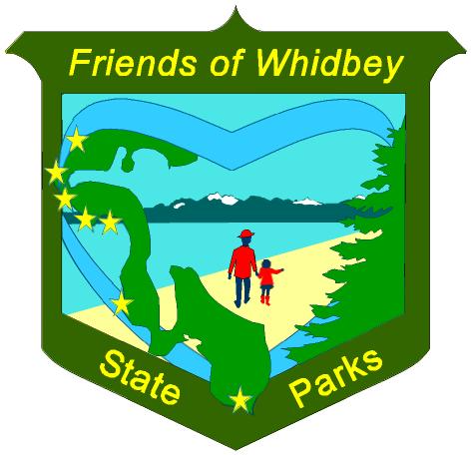 | Yes! I want to be a Friend of Whidbey State Parks!  Name(s) ___________________________________________________ Date __________  Address ___________________________________ City _________________ Zip _______
Phone Cell_____________________ or ____________________ Email __________________________________
Emergency Contact:____________________________________ Phone _________________________________
FOWSP will email updates to you. We will not share
Volunteer Opportunities-
Please √ all areas that interest you
Stewardship & Maintenance
Trail and Park Maintenance
Park Steward - Adopt-A-Trail/Park Area/Beach
Native Plant/Wildlife/Improving Habitat Projects
Fix-It or Construction Projects
Historic Preservation
Interpretive Programs
Jr. Ranger Programs/School Groups
Lighthouse - Docent/Gift Shop/Tour Guide
Fort Casey Battalion Tour Guide
Events (help organize, set-up, parking, clean-up)
Forest/Nature Walks
Graphic Design/Office Assistance
Social Media/Outreach
E-News Updates
Tech Support
Board of Directors
Fundraising/Sponsorship

your personal information with other organizations.

√ the Parks you prefer for Volunteering-
Joseph Whidbey
Fort Ebey Ebey’s Landing
Fort Casey Keystone Spit
South Whidbey Possession Point
Active Duty Yes Veteran Yes Neither
Member Support-
We welcome donations!
Your donation will be used to support our Friends work and activities in Whidbey State Parks
I/we would like to Donate $ ____________
Check to FOWSP included with this form
I donated through PayPal on the website
Thank you for your support!
We are a qualified 501 (c) (3) tax-exempt nonprofit.
Please contact us for special donations.
SSkills/Interests I would like to Share -
_________________________________________________

I/we support the Friends of Whidbey State Parks (FOWSP) Mission and agree to get approval from State Parks
and sign in on a State Park Volunteer Timesheet prior to starting any volunteer activities in the State Parks.
Volunteers Must Sign-In on a Volunteer Timesheet to be covered by WA State Labor & Industries Insurance.
I/we give FOWSP permission to use photographs & videos of me [and my family, no names unless permission given]
for the FOWSP Website, Facebook page and publicity to inform the community about the FOWSP mission.
Signature(s) _______________________________________________________ Date __________
Send completed form to: Friends of Whidbey State Parks
1280 Engle Rd. Coupeville, WA 98239-9805
Or scan and email to: fowspk@gmail.com
Go to: www.FriendsofWhidbeyStateParks.org for more information.
www.facebook.com/FriendsofWhidbeyStateParks
Thank you for supporting your local State Parks!

